**LVCA Meeting, Monday, November 11, 8pm, Community House**

The November Lyon Village meeting will feature School Board Member Reid Goldstein. He will discuss current issues facing Arlington Public Schools. Much of the meeting will be devoted to question and answers, so be sure to bring your school -related questions.

**Recap from October 14 General Meeting**

The October meeting featured three of the four County Board candidates. They are running for two open seats. Candidates who attended the meeting were Audrey Clement (independent), Katie Cristol, (incumbent Democrat), and Christian Dorsey (incumbent Democrat). Go to LyonVillage.org to hear what the candidates said.

**Beyer Writes FAA on Airplane Noise**

Rep. Don Beyer (VA-08) sent a letter to the Administrator of the Federal Aviation Administration expressing concerns about its recent announcement to make changes to flight paths at DCA to accommodate Secret Service needs without giving meaningful consideration to community interests. Beyer urged the FAA to delay implementation of the proposed changes to DCA flight procedures in order to engage the community.

**Lyon Village Women’s Club**

The Lyon Village Women’s Club’s "Very Merry Market" will no longer be taking place on December 1.

**Village Spotlight**

This month we are highlighting the work of **Lyon Village resident Keith Oberg**. In 2005 Keith founded the organization Bikes for the World, which collects used bikes for distribution to those in the greatest of need. The bikes are repaired if necessary. Some are distributed locally but most are sent overseas to Africa or the Caribbean nations. He has been doing this locally since 1995. The organization has collected over 200,000 bikes through the years. Keith was at the recent E-Care recycling event on October 19, doing what he does best, collecting about another 100 bikes for those in need of transportation.

Congratulations to the **[Cherrydale Volunteer Firehouse](https://lnks.gd/l/eyJhbGciOiJIUzI1NiJ9.eyJidWxsZXRpbl9saW5rX2lkIjoxMTUsInVyaSI6ImJwMjpjbGljayIsImJ1bGxldGluX2lkIjoiMjAxOTEwMjkuMTIxODIyMDEiLCJ1cmwiOiJodHRwczovL3Byb2plY3RzLmFybGluZ3RvbnZhLnVzL3Byb2plY3RzL2NoZXJyeWRhbGUtZmlyZS1ob3VzZS8ifQ.7HtCBEnVXNbggbTWNfHMUtg0uZOnqJ9EWQ0lVSZdPAw/br/70674808924-l" \t "_blank)** on turning 100 years old! This building was the first dedicated firehouse in the county and the model for all the first firehouses in the area. It has served more than one civic purpose since it was built, offering not only fire safety services but civic services in the community room upstairs. A little-known fact is that the building hosted the county’s first movie theater.

**Picturing Arlington 100 Years Ago**

Check out this interesting map and photos of what Arlington looked like 100 years ago, including a few pictures of Lyon Village, Clarendon, and Courthouse. Assembled by the Arlington Historical Society by local historian Charlie Clark. *Arlington Now* article and link here: <https://www.arlnow.com/2019/10/28/new-historical-map-of-arlington-shows-what-county-looked-like-100-years-ago/?mc_cid=7b3c769730&mc_eid=14024f783a>

**Lyon Village Dues are Due!!**

Dues for the September 2019–August 2020 fiscal year are due. The dues support LVCA activities, such as Holiday parties, the Spaghetti Dinner, and 4th of July picnic. Dues are $7 for individuals or $10 per household. Mail or deliver your payments to Don Gay at 1803 N. Highland St. (make checks payable to “LVCA”) or go to lyonvillage.org to pay via PayPal.

**Calendar**

**Nov. 5 Election Day**

**Nov. 11 LVCA Meeting**

]

**Holiday Food Drive: November 1 - January 4**

Once again the Arlington County Fire Department is teaming up with Arlington Food Assistance Center (AFAC) to help collect non-perishable food items for the holiday season. Food collection bins will be dropped off at Arlington County firehouses starting November 1 and will remain until January 4th. Last year AFAC was able to collect over 84,000 pounds of food for our neighbors. Please help those in our own community who are experiencing a food crisis by bringing nutritious supplemental groceries our firehouses.

**November 5: Election Day**

On the ballot will be all Virginia General Assembly offices (Virginia Senate and House of Delegates), Commonwealth’s Attorney, Sheriff, Commissioner of Revenue, Treasurer, County Board (two seats), and School Board. Polls are open 6am to 7pm at the Lyon Village Community House. Sample ballot here:

<http://lyonvillage.org/2019/09/06/nov-5-is-election-day/>

**Nov 16: County Board To Reconsider**

**E-Scooter Regulations**

Close to a half- million trips were taken on rental e-scooters in Arlington during the first 10 months of the pilot program. Trips during the summer averaged about 80,000 per month. After receiving staff’s evaluation of the year-long demonstration project, the county board will hold a public hearing and consider regulations for e-scooters and other shared mobility devices at its November 16 meeting. Board Chair Christian Dorsey said, “The demonstration project clearly showed these devices are serving a need and add another safer, more sustainable travel option than driving a car. We look forward to hearing from the public in November on the Manager’s proposals for regulating these devices in Arlington.”

The staff report found: “Scooters appear to improve accessibility, particularly to public transit. About 10 percent of respondents reported using transit more frequently than before, suggesting that the devices help bridge the last-mile gap.” The public hearing will allow the public to comment on the proposed regulations for these shared mobility devices. The pilot project found that the devices are well-used and popular among riders and offer potential community benefits, but it also found that there are challenges related to perceptions of the safety of riders and pedestrians, parking impacts on sidewalks, and the need for better riding infrastructure on streets.

The proposed revisions include allowing the devices to be used on county streets, sidewalks, and multi-use trails and putting in place a permit fee structure for private companies offering the devices. During the pilot program, the devices have been prohibited on county sidewalks. If you have comments or concerns about scooters, contact the county board office at 703-228-3130 or attend the meeting and sign up to be a speaker.

**Real Estate Corner – Thinking About Selling?**

A question we are often asked is ‘When is the best time to list my house for sale?’ While there are always buyers looking for their next home, as life doesn’t typically push all sales and purchases into a neat pattern, there are times of the year when many think it more ideal to list. But this can mean that there are more options, as other properties are also listed, so prospective buyers will have more choices. With the holidays approaching, and attention turning to friends and family gatherings, some buyers will focus on coming events and travel rather than continuing their home search full tilt. This can reduce the number of buyers actively looking at homes this time of year. This might be a signal that it’s best to wait to list a property for sale.

General market knowledge would indicate that after the New Year, especially after the Super Bowl (as our weather tends to get a little drier in mid-February), would be a good time to list. Buyers who have been searching may become discouraged by the properties on the market and the lack of choice available to them. New properties entering the market in the New Year receive more attention and potentially garner higher sales prices. If the weather indicates a snowy February, however, it may be better to hit pause on the listing and wait until the snow and ice have melted. No reason to have days on the market accumulating, as the snow does, as it’s harder to go see properties on the market.

Every situation, however, is individual. A particular home may look its best at the holidays - straight out of a storybook - making it the best time to list it. Ruth’s very first sale was a home listed on New Year’s Eve day. The key here is to talk to a professional who can tell you the demand, and buyer pool, for your home in the current market at the current time of year. In some neighborhoods, the demand is strong throughout the year. Or, a home is in a price range that is attractive and will do well regardless of when it’s listed.

This time of year is also ideal for planning, talking about what may need to be done (if anything) to your home to ready it for market, and getting to those honey-do lists. With the shorter days, we have time to focus on the indoor projects we haven’t addressed that may make a sale more seamless and occur more quickly.

As we have very few homes that are exactly the same, and very few needs and goals that are identical across sellers, each of us has different objectives. These can be met, regardless of the time year, with a well-thought-out marketing plan and approach created to meet the seller’s goals and take advantage of the home’s strengths.

*— Presented by Ruth Boyer O’Dea of TTR Sotheby’s International Realty and Billy Buck of Buck & Associates, Inc. Billy and Ruth can also be reached at lyonvillagerealestate@gmail.com.*

**Passing of Long-Time Lyon Village Resident Harold “Doc” Friedman**

We are sad to report that on Sunday, October 6, Dr. Sholom H. Friedman, long-time resident of Lyon Village, passed away. Known and beloved in the Washington area as Doc Friedman, he was the proprietor of Public Shoe Store, the family business founded in 1938.

The store closed in 2016 when Doc retired. A 7-11 store now occupies this location. Doc’s father Sam started the business. The store was originally located on the south side of Wilson Blvd. across from N. Hudson Street before that building was acquired to build the Clarendon Metro station. The store moved to its present location on the north side of Wilson Blvd. in the 1970s.

The area has changed dramatically since that time, but the one constant was Public Shoe Store, offering personal service and real solutions for sore feet. Style was not his thing, but comfort was. When the store moved across the street, Doc Friedman was working as a podiatrist in an office nearby. But when his father could no longer work in the store, he took it over for him and the rest is history. Every day he used to make the short trip to the store on his electric scooter from his house in Lyon Village.

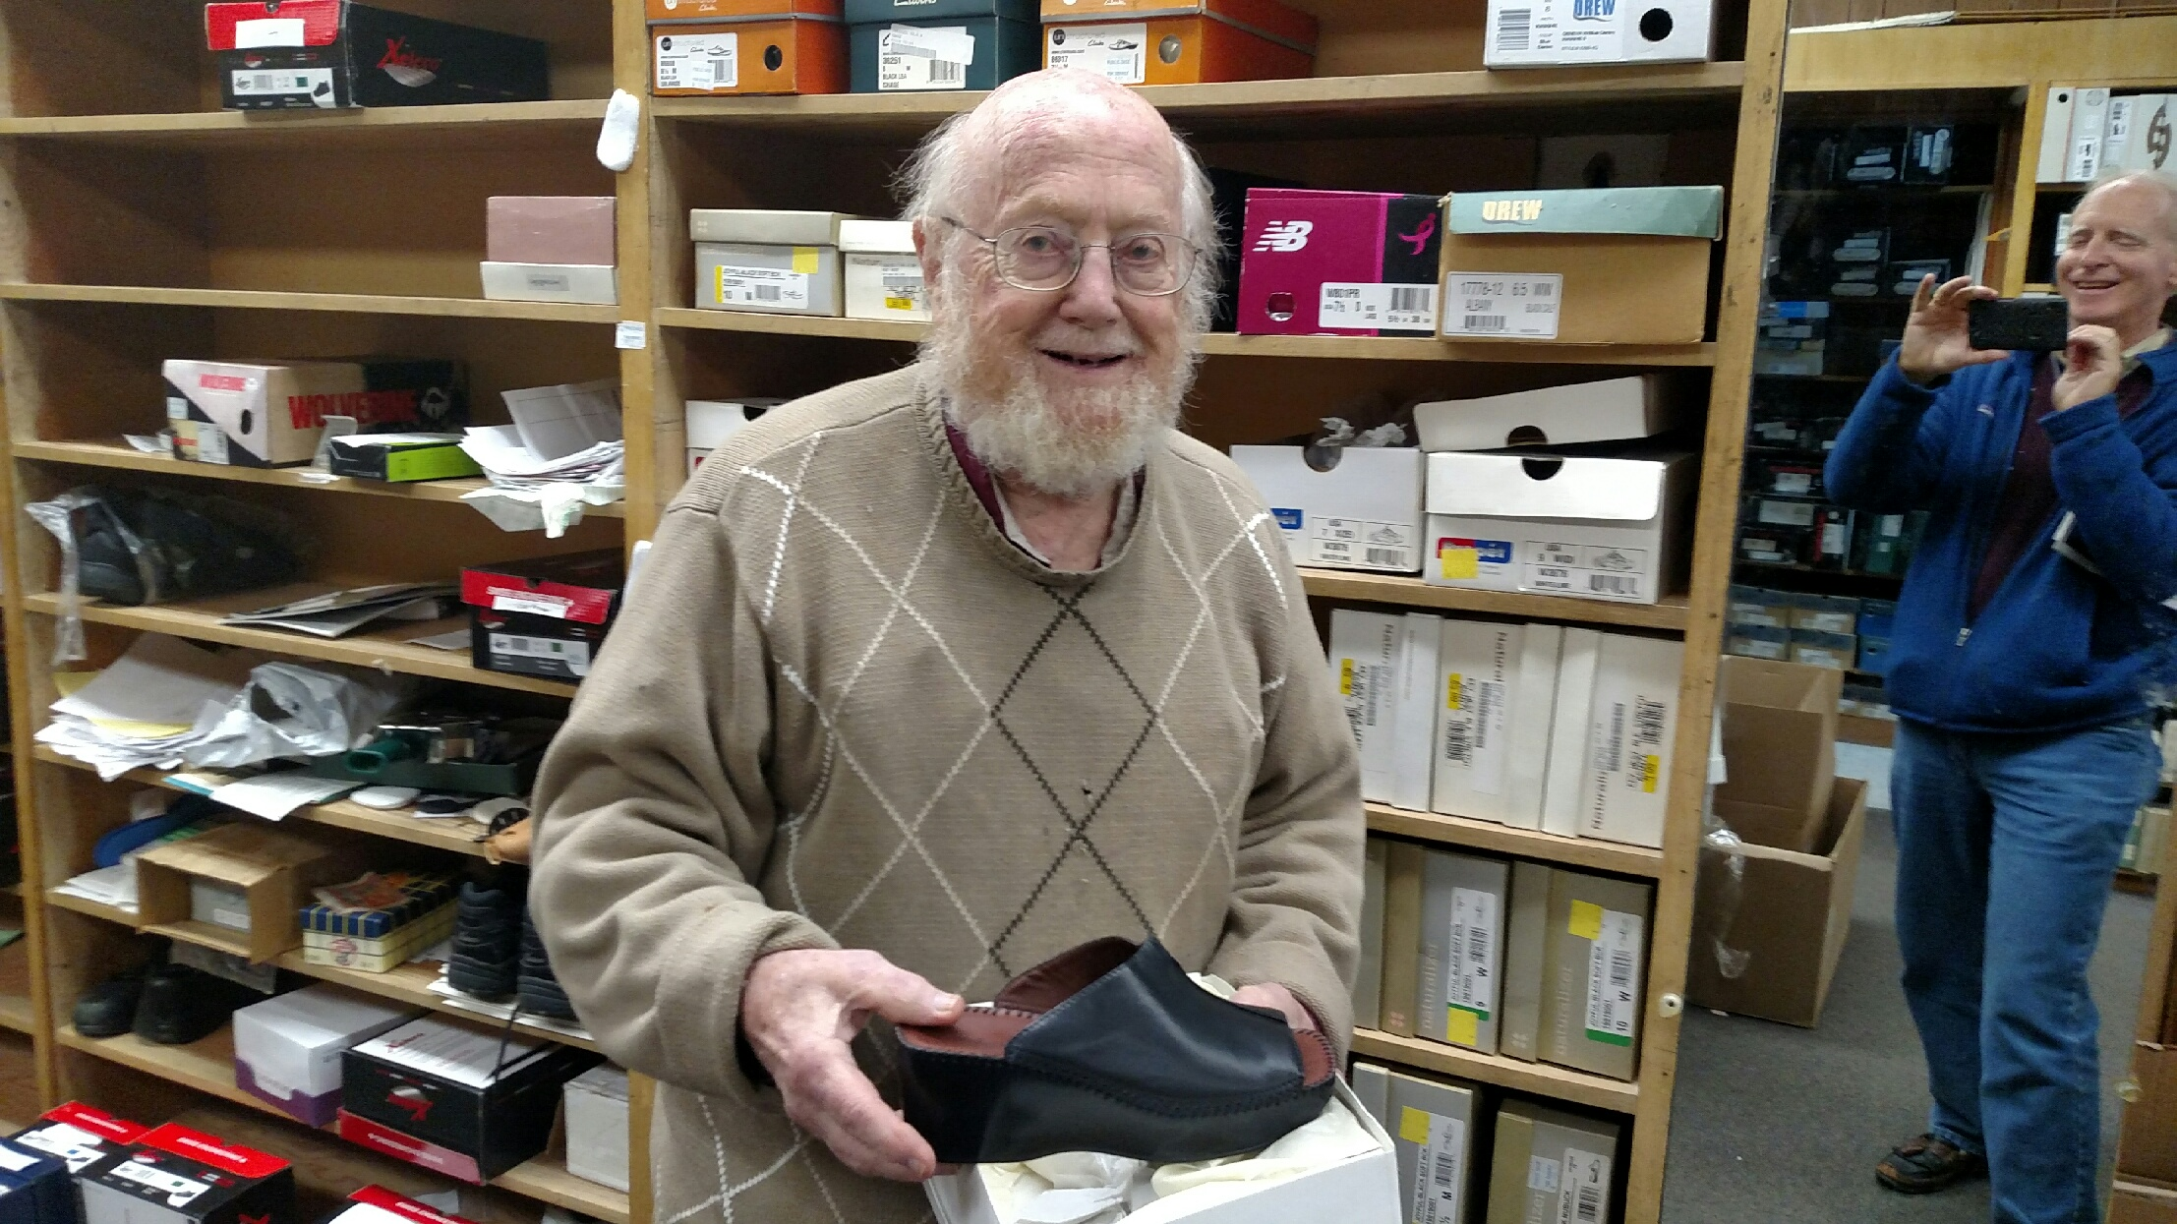

**Village Market**

**Gardener available for regular or occasional work.** Conscientious, reliable and very good worker.  For LV reference, please call 703-527-4533 or call Michael Tanu, 240-426-1778.

***Lyon Village residents are invited to send their notices of garage sales, nanny searches, and more to the Village Market by the end of the 3rd week of the month.***

Send your December 2019 *Bulletin* items to adam@ksaplus.com by **Nov. 24.**

SSend your Bulletin items to adam@ksaplus.com by **January 24, 2011.**